Vibration Sensor SW-420  
DESCRIPTION

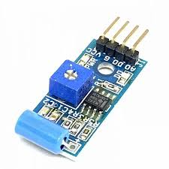

1.Detail:

Sensor Type: Vibration/Shock detection sensor.

Output: Analog and Digital

Operating voltage: 3.3v-5v

2.How it works:

The **SW-420 vibration sensor** works by detecting sudden vibrations or shocks .

When the sensor is ideal it gives the output ‘0’ and when the shock is detected then it will give ‘1’ at output. It will give output in ‘1’ and ‘0’ only for digital output.

For analog output it will have some numerical value, corresponding to vibration detected.

3.Pin Configuration

Vcc : 3.3v to 5v.

GND: Connect to ground.

DO: Digital Output -gives HIGH when vibration is detected and LOW when stable.

AO:Analog Output-gives the numerical value

4.Test Code:

void setup() {

// put your setup code here, to run once:

Serial.begin(9600);

pinMode(A2,INPUT);

}

void loop() {

// put your main code here, to run repeatedly:

int sensorvalue= analogRead(A2);

Serial.println(sensorvalue);

if(sensorvalue>400)

{

Serial.println("shock detected\n");

}

delay(100);

}

